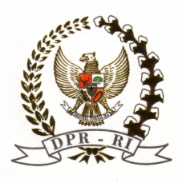 | HOUSE OF REPRESENTATIVES OF THE REPUBLIC OF INDONESIA  PARLIAMENTARY UNION OF OIC MEMBER STATES | 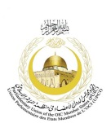

As of 14 September 2012

Parliamentary Event on Interfaith Dialogue

Theme: “The Parliamentary Role in Promoting Interfaith and Intercultural Cooperation

21 – 24 November 2012, Bali, Indonesia

List of Parliaments and Organizations

Parliaments:

      - Albania
      - Australia
      - Austria
      - Bosnia Herzegovina
      - Brunei Darussalam
      - Cambodia
      - Chad
      - China
      - Denmark
      - Egypt
      - France
      - Germany
      - India
      - Indonesia
      - Iran
      - Japan
      - Lao PDR
      - Malaysia
      - Morocco
      - Myanmar
      - Netherlands
      - Norway
      - Philippines
      - Qatar
      - Republic of Korea
      - Russian Federation
      - Saudi Arabia
      - Singapore
      - Thailand
      - Tunisia
      - Turkey
      - United Kingdom
      - United States of America
      - Vietnam
      - European Parliament

International Organizations:

      - Parliamentary Union of the OIC Member States (PUIC)
      - Organization of Islamic Cooperation (OIC)
      - World Muslim League
      - World Council of Churches

National Organizations:

      - Pusat Kerukunan Umat Beragama (PKUB)
      - Majelis Ulama Indonesia (MUI)
      - Nahdlatul Ulama
      - Muhammadiyah
      - Persekutuan Gereja-gereja di Indonesia (PGI)
      - Konferensi Wali Gereja Indonesia (KWI)
      - Parisada Hindu Dharma Indonesia (PHDI)
      - Perwakilan Umat Buddha Indonesia (WALUBI)
      - Majelis Tinggi Agama Konghucu Indonesia (MATAKIN)
      - Forum Kerukunan Umat Beragama (FKUB) Bali

